**Moving forward through THE EPIC ROAD**

1. I stand ____________ ***a*** ____________***series of*** ____________, e____________in a ____________that ____________both the rocks and the sky an unusual ____________of Mars***.*** I might indeed be ____________***into*** believing I'm on another planet altogether, ____________***it not for*** the ____________***of road that*** ____________***through the center of the valley*** and reminds me that others have ____________***their way into the*** ____________of this place before me. (这段描写有什么特色)

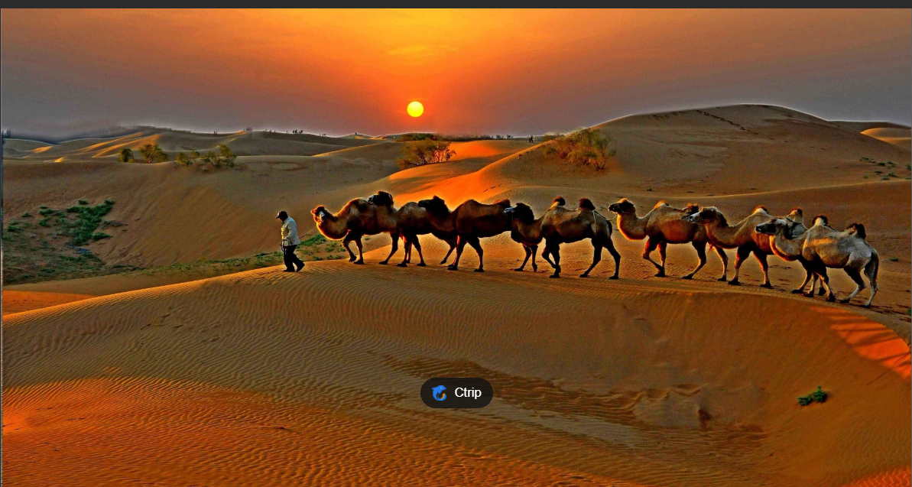

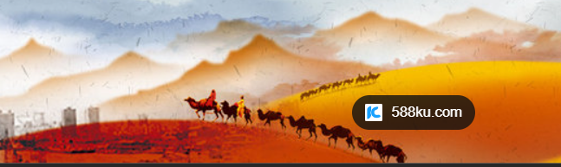

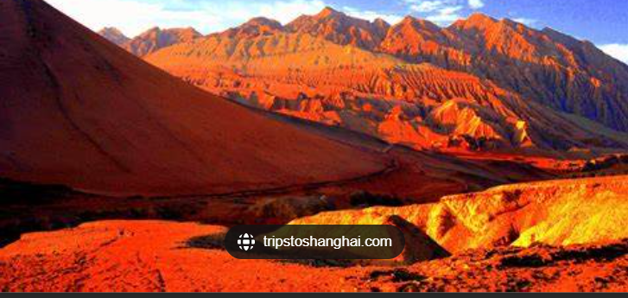

1. One of the first Europeans to ***set*** __________***for t***hese lands was the __________***explorer*** and writer Marco Polo, who__________***far from his own country*** and ***into Yuan Dynasty-era China*** in 1275. "I did not write half of what I saw, for I knew it would not be believed," he wrote in his __________ of the period.

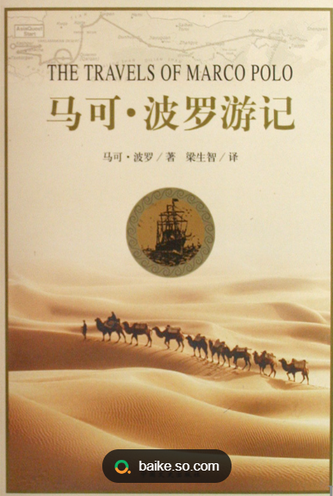

1. Like ***our journey through*** __________***of evolutionary changes***, the Silk Road is a trip that is considered important to the human condition. It may not be the first story of human movement, recorded or __________, but it is perhaps the most __________. The Silk Road was a series of trade routes that began thousands of years before the __________***Era*** and lasted until the 15th or 16th century (though many scholars argue that it continued for much longer). ***Over the*** __________, as ***kingdoms*** __________***and*** __________and conquerors __________broad areas of what is now Central Asia, the Middle East and Southern Europe, the route ***swerved and shimmied***, crossing mountains and deserts and eventually even the sea. __________west from the ancient city of Chang'an (now Xi'an) in China ***trundled*** __________of silk, tea, paper, and spices, __________***toward t***heir destinations in Rome or Constantinople; heading east came glass, gold, silver and horses. The route was some 4,000 miles, and dangerous; the people who traveled along it knew that they could be _________***by*** _________***both human and*** _________***,*** that at any moment, the lands they _________could become _________***territory.***
2. And so why did they persist, these early travelers? For one thing, there was their curiosity, ***their*** _______***for the new***, as _______to our condition as hunger or _______（analogy）. It wasn't just new objects or technologies that they encountered on the route; it was new ideas, new _______and new cultures（什么修辞）. To travel was to risk not only _______danger, but a different kind of risk as well — the chance that you might _______what you'd always believed for some other _______altogether. The road could change you so _______that you might never again be _______back home.
3. For another, there was the_______***of adventure***. Yes, the path was dangerous. Yes, you might never see your family again. But movement is also_______ ***to the human experience.*** It is why ***the*** _______***of the Silk Road*** _______***all these years later:*** Although you can _______***it as the first, most*** _______***experiment in*** _______, you can also ***see it as a*** _______***to not just our desire, but our need to explore***. Every traveler who leaves home therefore _______***in the spirit of our Silk Road*** _______, _______***out of our known world i***n the hope that we might be _______.

[6] I had always been _______by the same desire for adventure and exploration. And so this May, I arrived in Gansu Province to _______***a small part of Polo's*** _______***route***, voyaging from the city of Lanzhou to ***the Buddhist*** _______***of Dunhuang***.

[7] I _______***through*** wide rivers and _______***rock*** _______, encountered beautiful oasis cities, listened to ***sand*** _______sing and ***lost myself in rainbow-ridged mountains (此句为何吸引人)***. I also passed construction sites, _______***neighborhoods*** and trucks _______***on superhighways*** ***stretching for thousands of kilometers*** _______***,*** which is part of "the New Silk Road." Sometimes it seemed like I w***as being*** _______***back in time*** — at others, ***forward into a*** _______***future land***. (翻译本段)

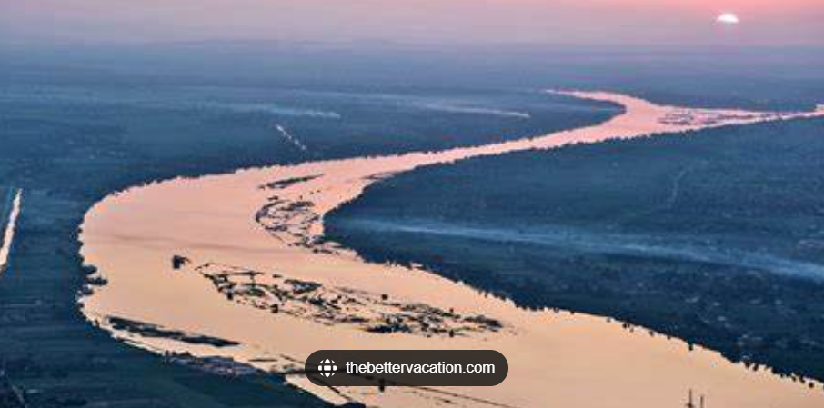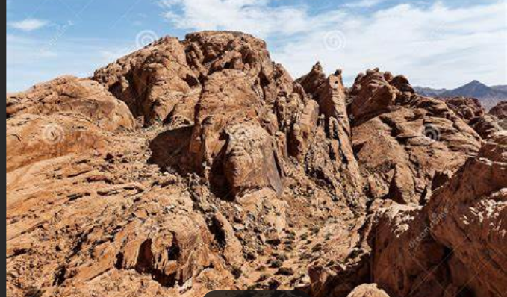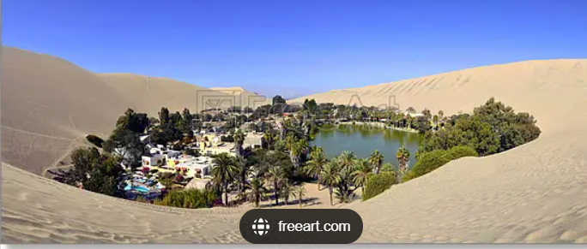

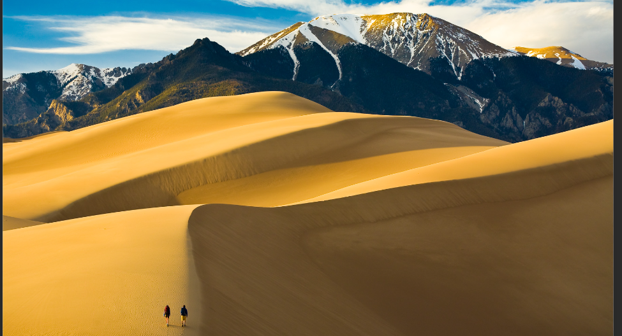

1. And toward the end of my trip, I realized that the Silk Road has more lessons to offer us in this moment than I'd previously thought. While it is ***a*** ______________***f our desire for*** ___________, it is also a reminder that open borders and movement bring wonder and awe to our lives, although they may also be accompanied by hardships and sorrows. ***Over the*** ___________***of the Silk Road's operation***, humanity had to ___________***with some of the toughest challenges in*** ___________***history.*** The journey was ___________, ***the risks,*** ___________***or political, were*** ___________, and ***the dangers were*** ___________***serious***. Travelers struggled with ___________***deserts,*** ___________***mountains***, and harsh weather. They also faced robbery, starvation, and ***other forms of*** ___________***.*** Numerous travelers lost their lives along the way, never being able to ___________with their family and friends.

[9] But for all these hardships and sorrows, the journey continued. Trade continued. Exchanges among different ___________continued. The need to discover new things and new people, to ***look*** ___________***the road*** ___________, continued. What else could they do, those pioneering travelers? They could ***no more*** ignore what they desired ___________they could ___________***what centuries of exploration and*** ___________***had taught them***. （什么修辞？） ***The only way*** ___________（什么修辞？）was forward.

[10] It is the same for us today. The only way through is forward. Let us find some comfort, though, in the knowledge that ***we are*** ___________***by centuries of human endurance***, by those travelers who remind us that the journey, no matter how difficult, ___________up ***as an epic road worth taking***.